AIAB -

Functionality
An asset that you produce in-house has two stages in its life that are relevant for accounting from the point of view of your company:
- Under construction phase
- Useful life (on commissioning of the asset)

The balance sheet should disclose the different phases in which the Assets are; therefore, it is necessary to manage the asset as a separate object or asset master record during the construction phase. The activity that records the change from Phase 1 to Phase 2 is called "capitalization of the asset under construction". The asset under construction (AuC) can be managed in the system in two different ways, depending on the types of functions that you need. The AuC can be either a normal asset record, or a master record with line item management. Before an asset can be “settled” to another asset / object, a distribution rule is assigned to the asset master record.

Scenario
The transfer from the AuC to completed fixed assets can be handled in one of two ways:
Summary transfer from a normal asset master record to the receiver assets (transaction type 348/349)
Line item settlement of an asset under construction that has line item management. The assignment of a distribution rule is illustrated in this system task.

Requirements
Asset master records with respective properties should have been created.

Menu Path | Accounting → Financial Accounting → Fixed Assets → Posting → Capitalize Asset u. Const. → AIAB - Distribute
Transaction Code | AIAB

1. Double Click on AIAB - Distribute

Settlement AuC: Initial screen

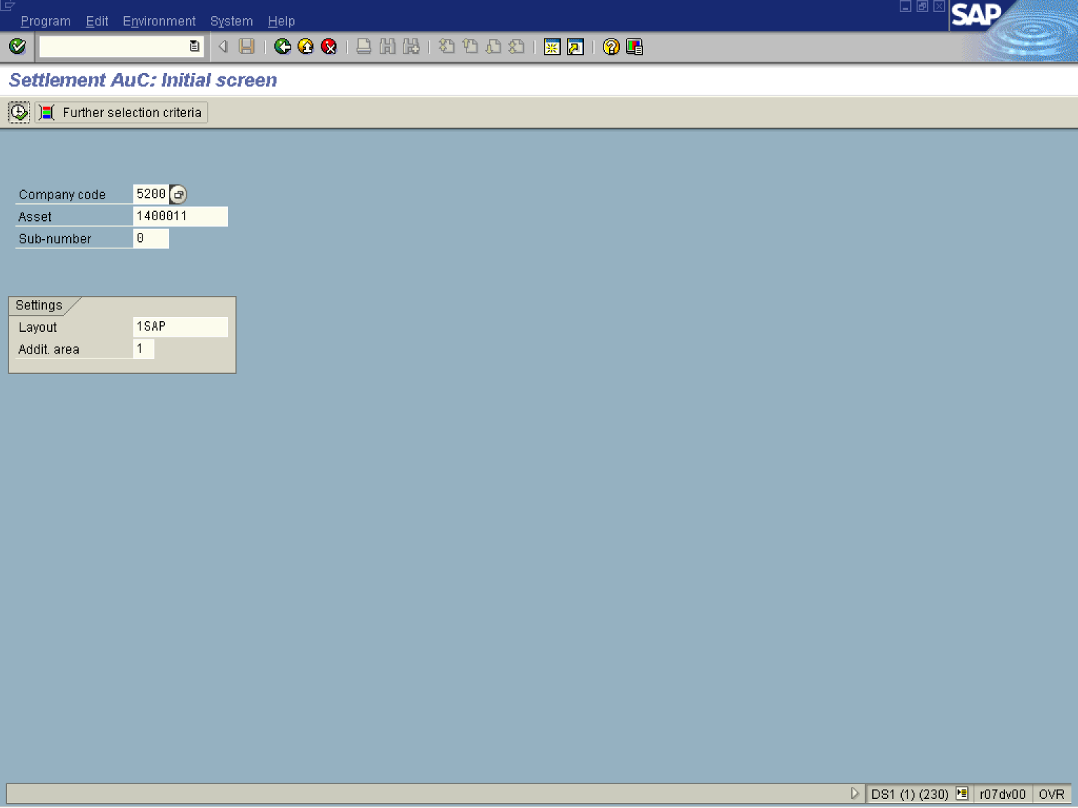

2. Update the following fields:

Field Name | Field Description | Values
Company Code | The company code is an organizational unit within financial accounting. | Example: 5200
Asset | Enter the asset number to be settled. Typically this is an Asset Under Construction. | Example: 1400011

3. Click the Enter button to Validate the entries.
4. Click Execute .

Settlement AuC: Line item list

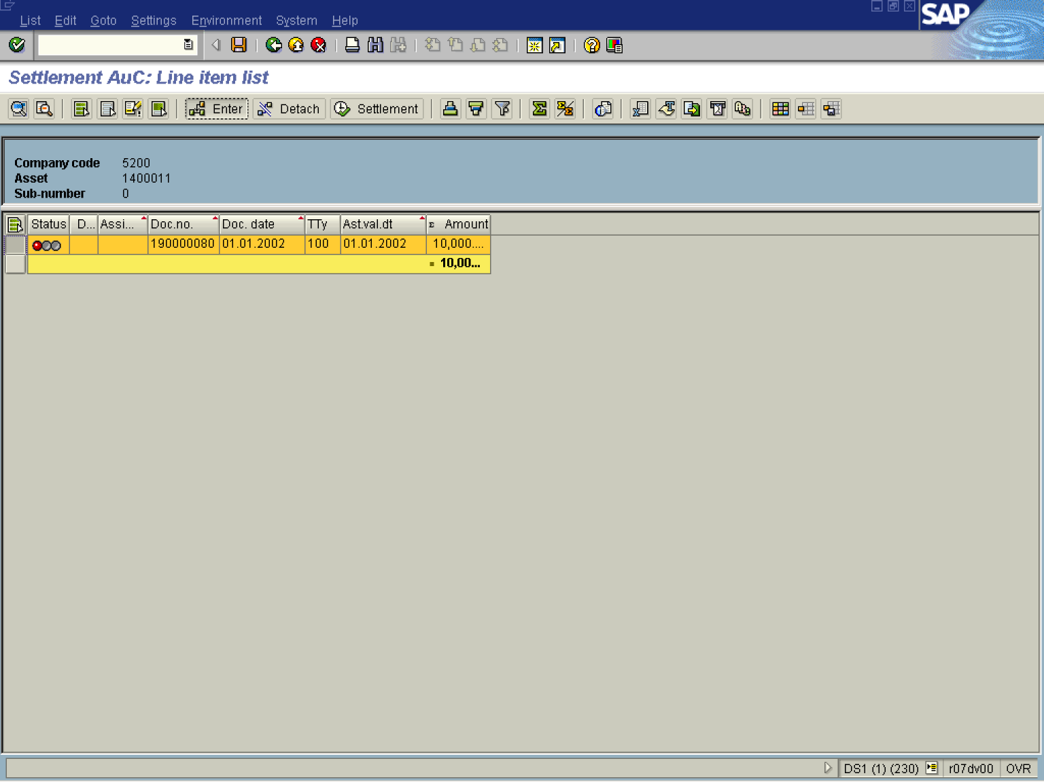

5. Click Enter Assignment Button .

Maintain Settlement Rule: Overview

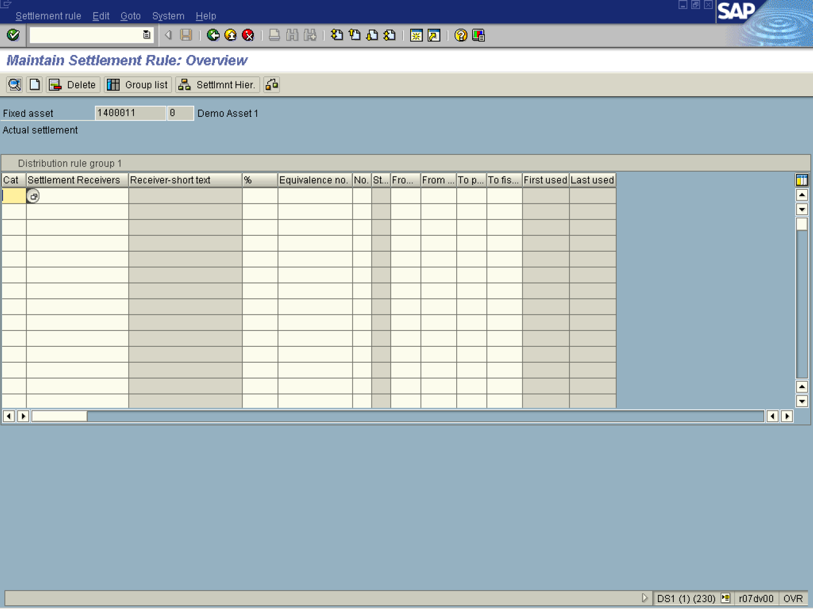
6. Click Matchcode Button 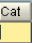.

Acc. assignment cat. (1) 1 Entry found

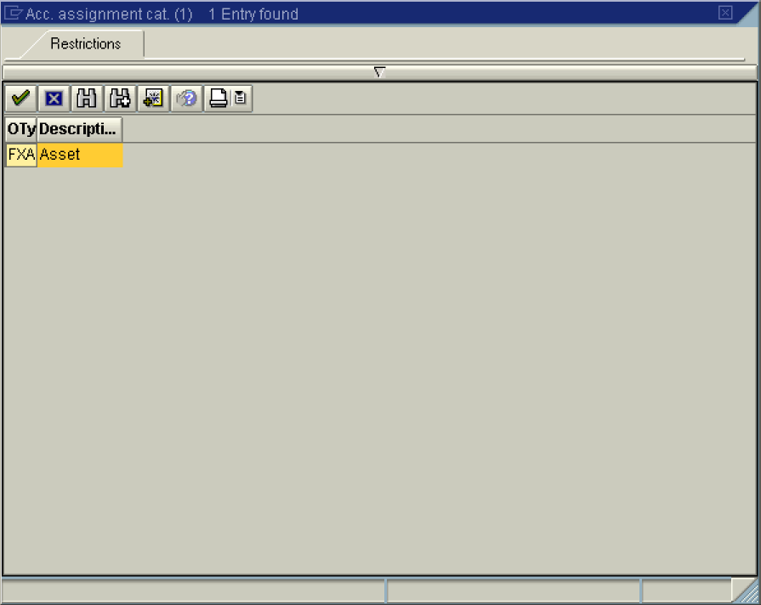

7. Select FXA - Asset in list box.

8. Click the Enter button.

Maintain Settlement Rule: Overview

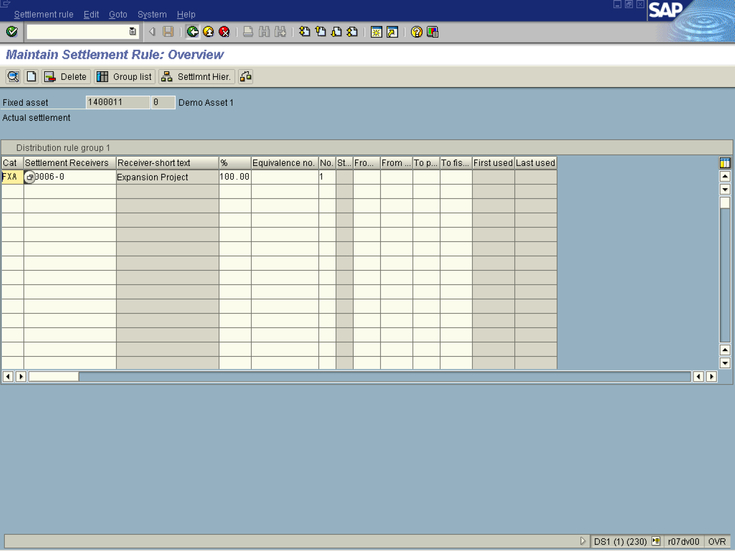

9. Update the following fields:

Field Name | Field Description | Values
Settlement Receivers | Enter the receiver of the cost to be settled. | Example: 300006
% | Enter the percentage value. | Example: 100
10. Click the Enter button to Validate the entries.
Note: To settle by amount instead of percentage, double click on the settlement rule. This will take you to a screen that allows you to enter an amount instead of percentage.
11. Click the Save button.
Settlement AuC: Line item list

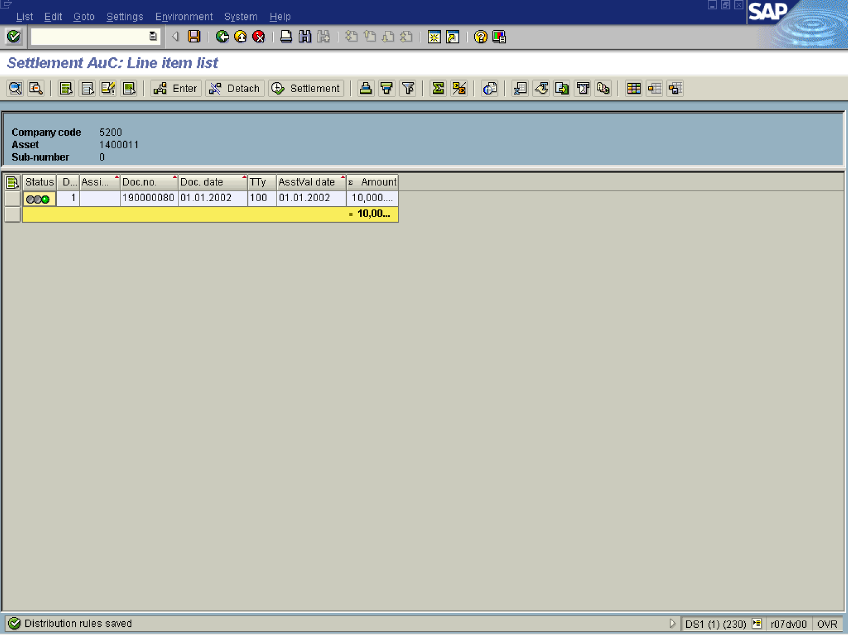

12. The message bar displays “Distribution Rule Saved”

